| **North South University**  Department of Electrical & Computer Engineering  **LAB REPORT-** 04  Course Code: EEE111L  Course Title: Analog Electronics  Section: 6  Lab Number: 04  Experiment Name:  Experiment Date: 25th March 2023 and 1th April 2023  Date of Submission: 15th April 2023  Submitted by Group Number: Group - 04  Group members:   | Name | ID | Obtained Mark Simulation [5] | Obtained Mark Lab Report [15] | | --- | --- | --- | --- | | 1. Muhammad Raiyan Alam | 1831100642 |  |  | | 2. Sadia Tahasin | 1921397042 |  |  | | 3. Md. Shahidul Islam | 1822169642 |  |  | | 4. Mosroor Mofiz Arman | 1921079642 |  |  |   Course Instructor: Dr. Mohammad Shorif Uddin (MHUd)  Submitted To: Md. Anisur Rahman Asif |
| --- | --- | --- | --- | --- | --- | --- | --- | --- | --- | --- | --- | --- | --- | --- | --- | --- | --- | --- | --- | --- |

1. **Experiment name:** Zener Diode applications
2. **Objectives:** To study about the Zener Diode applications.
3. **Apparatus:**

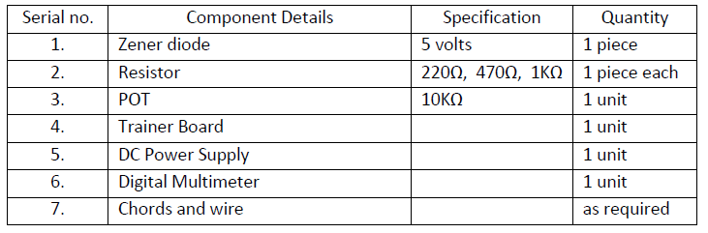

1. **Theory:**

The Zener diode may have a breakdown voltage from about 2 to 200 volts. These diodes can operate in any of three regions – forward, leakage and breakdown. Figure 4.2 shows the I-V characteristics curve of Zener diode.

In the forward region it works as an ordinary diode.

In the leakage region (between zero and breakdown) it has only a small reverse saturation current.

The Zener diode can operate in any of three regions – forward, leakage and breakdown.

* In the forward region it works as an ordinary diode.
* In the leakage region (between zero and breakdown) it has only a small reverse saturation current.
* In the breakdown it has a sharp knee, followed by an almost vertical increase in current without changing the voltage.
* The voltage is almost constant, approximately equal to Vz over most of the breakdown region.

1. **Circuit Diagram:**

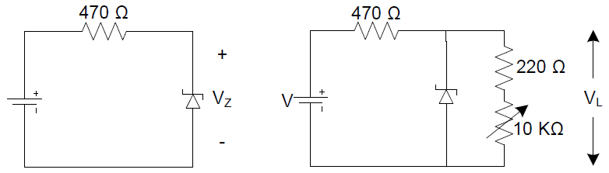

**6) Experimental Procedure:**

1. At first we connected the Ziode Diode, 470 ohm and the DC source in a series circuit.
2. Then we supplied the Supply Voltage starting from 0V to 14V depending on the Voltage we were instructed to supply
3. Then, we built the 2nd circuit. In the second circuit, the ziode circuit and 220ohm and 10K variable voltage were parallel to the ziode diode. Again, these ziode diode, 220ohm and 10K variable voltage were series connected to another 470ohm resistor. We also supplied a DC power source in the circuit. The overall circuit looked like the 2nd circuit that is drawn in the Circuit Dragram.
4. The variable resistor aka is known as the POT was kept at 10V.
5. The POT was decreased to 0V starting from 10V. And a Reading was written.
6. The load was replaced with 1KΩ, the supply was varied and a reading was taken in the below table.
7. **Results and Analysis:** compare all the results (theoretical,simulated, and practical) collected during the lab experiment.

After fulfilling the data of Table 5.1, we can see that, the Zener Diode accomplishes the characteristic of IV.

From Table 5.2, we can also learnt that, by regulating load variation to a Zener diode, we can achieve a stable voltage output, which is useful in many electronic applications, such as power supplies, voltage references, and voltage regulators.

From Table 5.3, we can also learnt that, By regulating due supply voltage variation to a Zener diode, we can achieve a stable output voltage, which is useful in many electronic applications, such as power supplies, voltage references, and voltage regulators.

8) **Questions and Answers (Q/A):**

1. **Plot the I - V characteristics of Zener diode. Determine the Zener breakdown voltage from the plot.**

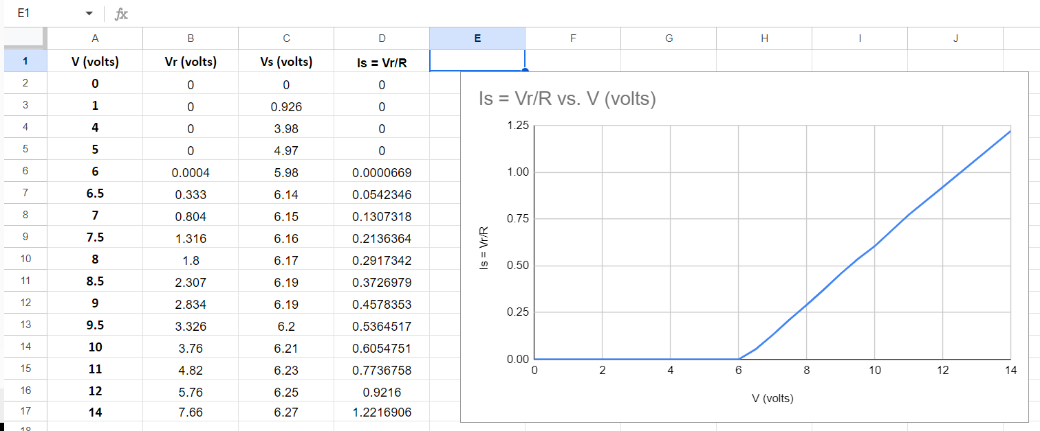

1. **Plot IL vs VL for the data table 4.2. Find the voltage regulation.**

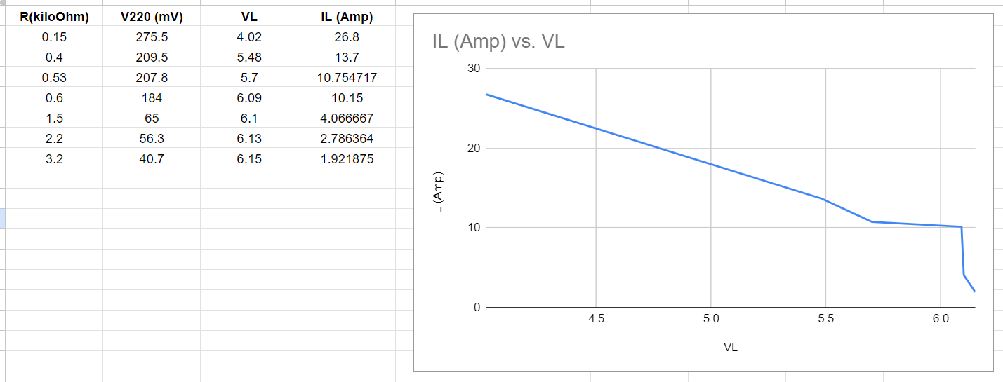

1. **Plot VL vs V for the data table 4.3. Find the voltage regulation.**

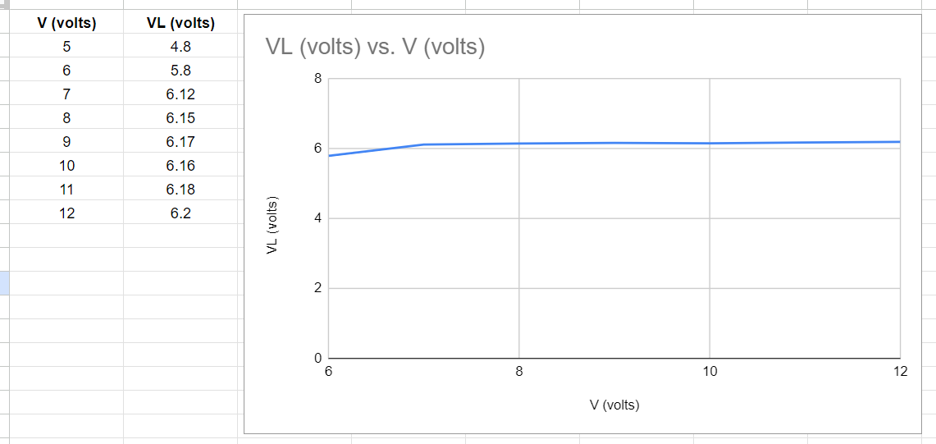

**Add:**

* Experimental Data Table:
* Discussion (write in your own words)
* Simulation: